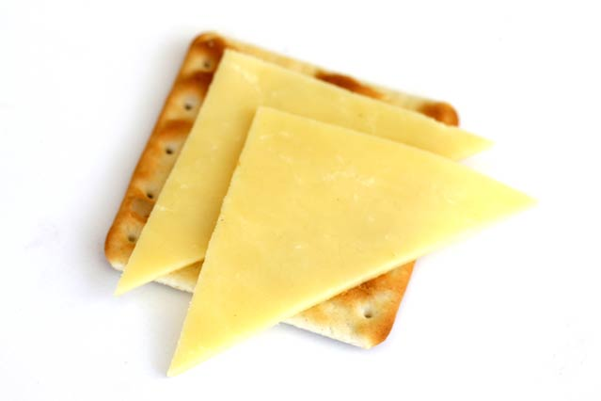 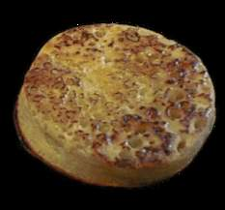

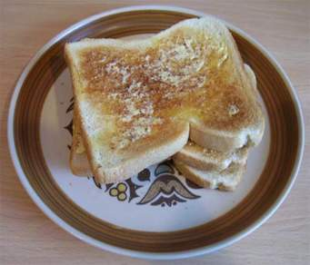

**Moss Side Playgroup**

**Snack Menu and listed allergens**

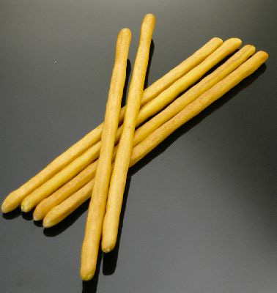 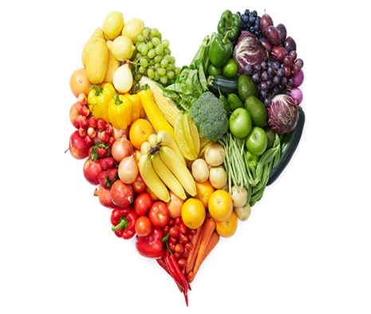

**Monday**

**Drinks**

Milk

Water

**Allergens: milk**

**Snacks**



**Toast - Co-op bread (wholemeal bread) - Brown wheat, yeast, salt, spirit vinegar, soya flour, vegetable oil - rapeseed & palm, mono & diacetyl tartaric acid esters of mono diglycerides, preservatives - calcium propanatel, flour treatment agent - ascorbic acid**

Allergens: wheat, soya and may contain barley, oats & rye

**Toast - Co-op bread (white bread) - Fortified wheat flour, wheat flour, yeast, salt, spirit vinegar, salt, soya flour, vegetable oil - rapeseed & palm, mono & diacetyl tartaric acid esters of mono diglycerides, preservatives - calcium propanatel, flour treatment agent - ascorbic acid**

Allergens: wheat, soya and may contain barley, oats & rye

**Vitalite margarine** - Contains: sunflower, palm and rapeseed oil, water, salt, Emulsifiers E471, Sunflower lecithin, preservative potassium sorbate, lactic acid, colours annatto, curcumin, (B vitamins niacin B6, B2, Folic acid & B12) niacin

**Selection of fruit and vegetables**

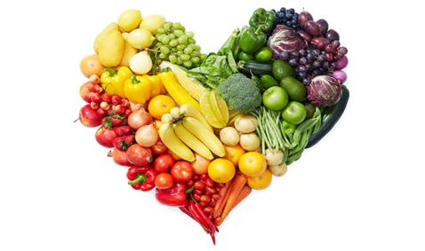

**Tuesday**

**Drinks**

Milk

Water

**Allergens: milk**

**Snacks**



**Warbutons crumpets** - containing - Wheat, yeast, raising agents E450 E500

**Allergens: wheat**

Vitalite margarine - Dairy free, Soya free, gluten free

Contains sunflower, palm and rapeseed oil, water, salt, Emulsifiers E471, Sunflower lecithin, preservative potassium sorbate, lactic acid, colours annatto, curcumin, (B vitamins niacin B6, B2, Folic acid & B12) niacin

**Selection of fruit and vegetables**

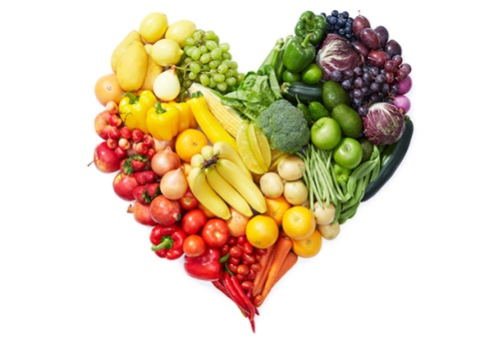

**Wednesday**

**Drinks**

Milk

Water

**Allergens: milk**

**Snacks**



**Toast - Co-op bread (wholemeal bread) - Brown wheat, yeast, salt, spirit vinegar, soya flour, vegetable oil - rapeseed & palm, mono & diacetyl tartaric acid esters of mono diglycerides, preservatives - calcium propanatel, flour treatment agent - ascorbic acid**

Allergens: wheat, soya and may contain barley, oats & rye

**Toast - Co-op bread (white bread) - Fortified wheat flour, wheat flour, yeast, salt, spirit vinegar, salt, soya flour, vegetable oil - rapeseed & palm, mono & diacetyl tartaric acid esters of mono diglycerides, preservatives - calcium propanatel, flour treatment agent - ascorbic acid**

Allergens: wheat, soya and may contain barley, oats & rye

**Vitalite margarine** - Contains: sunflower, palm and rapeseed oil, water, salt, Emulsifiers E471, Sunflower lecithin, preservative potassium sorbate, lactic acid, colours annatto, curcumin, (B vitamins niacin B6, B2, Folic acid & B12) niacin

**Selection of fruit and vegetables**



**Thursday**

**Drinks Provided**

Milk

Water

Allergens: milk

**Snacks Provided**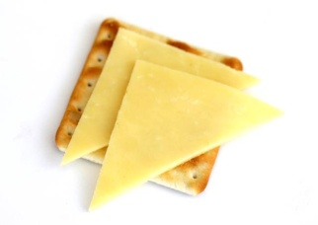

**Cheese and crackers**

contains: Wheat flour, calcium carbonate, niacin, iron, thiamin, palm oil, salt, raising agent sodium hydrogen carbonate, yeast.

Allergens: Wheat, milk

**Vitalite margarine** - Contains: sunflower, palm and rapeseed oil, water, salt, Emulsifiers E471, Sunflower lecithin, preservative potassium sorbate, lactic acid, colours annatto, curcumin, (B vitamins niacin B6, B2, Folic acid & B12) niacin

**Selection of fruit and vegetables**



**Friday**

**Drinks**

Milk

Water

**Allergens: milk**

**Snacks**



**Warbutons crumpets** - containing - Wheat, yeast, raising agents E450 E500

**Allergens: wheat**

Vitalite margarine - Dairy free, Soya free, gluten free

Contains sunflower, palm and rapeseed oil, water, salt, Emulsifiers E471, Sunflower lecithin, preservative potassium sorbate, lactic acid, colours annatto, curcumin, (B vitamins niacin B6, B2, Folic acid & B12) niacin

**Selection of fruit and vegetables**



**Alternative Snacks**

**Drinks Provided**

Milk

Water

**Allergens: milk**

**Snacks**



**Bread sticks - containing - wheat flour, olive oil, malted barley extract, salt**

**Allergens: wheat, barley, (may also contain sesame, soya, milk)**

**Selection of fruit and vegetables**

